# **Sprint Retrospective (sprint 1)** September 28th

**Scrum Master: Nathan**

o What went well

Completed all the tasks we thought we could.

Meeting as a group every class period.

Prototypes are working and no breaking point errors.

o What didn't go well

Presenting our prototypes with customers.

Getting databases to work on different systems.

o What specific things you can do to improve

We will prep beforehand for our next presentation.

Put the time/date of the next meeting in the chat.

o List the measurement criteria

|  |  |  |  |
| --- | --- | --- | --- |
| Name | Familiarize with tech stack | Percentage of work done | Stress |
| Peter Allen | 20 | 25 | 25 |
| Nathan Johnson | 20 | 25 | 30 |
| Jared Scottt | 25 | 25 | 25 |
| Braysen Goodwin | 35 (used stack before) | 25 | 20 |

## 

# **Sprint Planning (sprint 2 - Oct 19)**

**Nathan’s idea of time**

User Stories Supported With Code:

Account Information Change small 5% *this sprint

* A user should be able to change the information on their account

Managing User Accounts small 5% *this sprint

* An manager should be able to change the roles on other users

Restock/Discard Inventory medium 10% *this sprint

* A chef should be able to add and remove stock from inventory

Place Order large 15% *this sprint

* A customer should be able to place an order
  + Customer can pick any number of bagels
  + Customer can pick any number of toppings for the bagel
  + Customer can place order (if user has adequate funds)
  + Customer will receive prompt they do not have adequate funds if applicable

Marking Order As Picked Up medium 10% this sprint to next

* A cashier should be able to mark an order as picked up

Marking Order As Prepared medium 10% next sprint

* A chef should be able to mark an order as prepared

Viewing and Printing Analytics medium 10% next sprint

* A manager should be able to view order and menu analytics

Unit tests of created logic large 15% next sprint

* Tests should be able to detect problems in the code

*Leftover bugs and such for final* 20%

Create Navigable Pages:

HomePage:

Order Page:

Chef Order Page:

Cashier Page:

Inventory Page:

Account Page:  
 Account Database:

Inventory Database:

Order Database:

Unit Tests covering major logic:

Order placement

Inventory management

Account creation

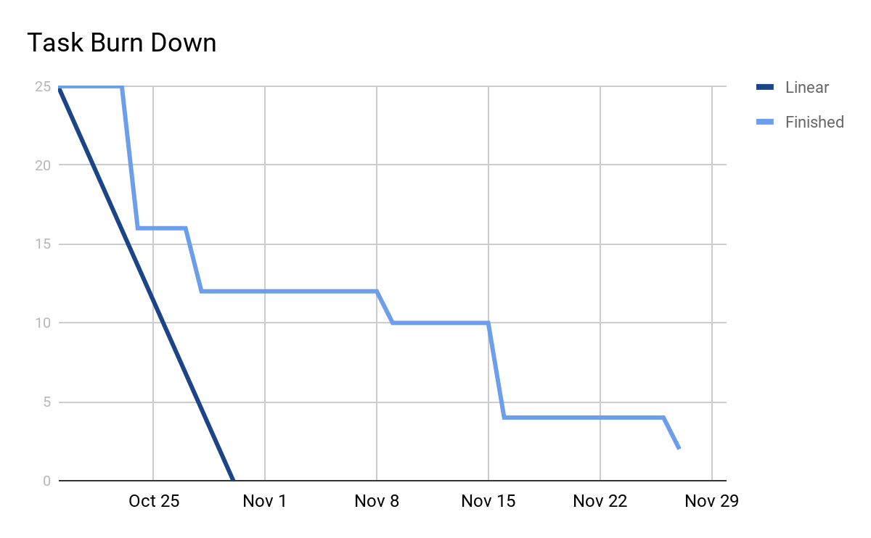

October 28 update:

What is missing for this sprint:

Backend:

Get analytics finished today)

Get needed route

Frontend:

Order page (routes: Nathan)

Account sign up/ login/ account page (routes: Nathan)

Basic containers (Jared)

Inventory page (routes: Nathan)

**Standup Summaries**

**Oct 19, 2020:**

Worked on:

No one did anything between last standups

Concerns:

No concerns were raised

Today:

Work on sprint planning

**Oct 21, 2020:**

Worked on:

All members worked on documents and sprint timelines between standups. All documents in the github repo should now be up to date.

Concerns:

No concerns were raised

Today:

Peter - work on front end with Jared

Jared - work on front end with Peter

Braysen - work on backend with Nathan, get tests and authentication running

Nathan - work on backend with Braysen

**Oct 23, 2020:**

Worked on:

Most members had some difficulties with getting the code running on their computers. Everything should now be running.

Concerns:

Concerns about the tasks we have assigned out and not being able to get them done. We planned on finishing everything in two sprints, so going a little over on this sprint should be ok.

Today:

Peter - work on front end pages with Jared

Jared - work on front end pages with Peter

Braysen - work on backend with Nathan, get tests and authentication running

Nathan - work on backend with Braysen

**Oct 26, 2020:**

Worked on:

Braysen finished a lot of the backend, still missing /analytics and /order routes. Nathan worked on reviewing Braysen’s merge requests. Jared worked on getting more familiar with react. Peter did not show up to standup.

Concerns:

Peter did not show up to standup and we are meeting with the professor almost directly after this meeting.

Today:

Peter - work on front end pages with Jared

Jared - work on front end pages with Peter

Braysen - work on backend with Nathan, get order routes working

Nathan - work on backend with Braysen, get analytics routes working

**Oct 28, 2020:**

Worked on:

Braysen worked on the /order routes. Nathan worked on the /analytics route. Jared worked on getting more familiar with react. Peter did not show up to standup.

Concerns:

Peter did not show up to standup and did not show up for a previous meeting with the professors on Monday. We attempted to contact him but have not heard back.

Today:

Peter - work on front end pages with Jared

Jared - work on front end pages with Peter

Braysen - work on backend with Nathan, get order routes working

Nathan - work on backend with Braysen, get analytics routes working

**Oct 30, 2020:**

Worked on:

Braysen worked on the /order routes and reviewed Nathan’s code. Nathan worked on the /analytics route and reviewed Braysen’s code. Jared worked on styling components in react.

Concerns:

We still have not been able to contact Peter, and client side is far behind on the time line.

Today:

Peter - work on front end pages with Jared

Jared - Created general react components to be used within the front end.

Braysen - work on backend with Nathan, get order routes working

Nathan - work on backend with Braysen, get analytics routes working